Identification | Form (elements of art and design principles) | Art-making process (materials and techniques)
Content (subject/iconography) | 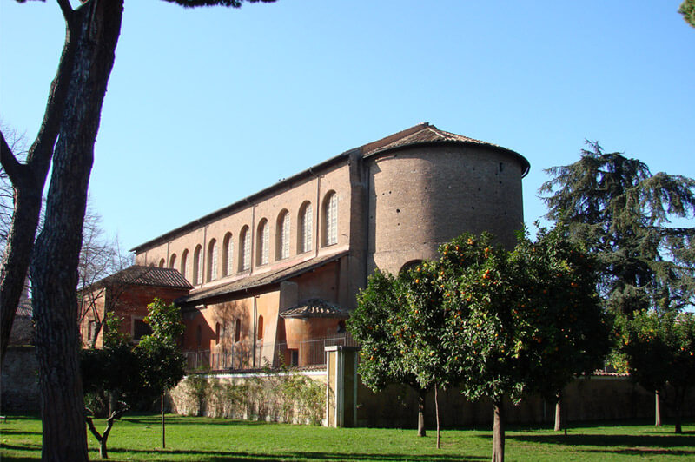 | Original context/audience
Intended function/purpose | Artistic innovation/convention | Thematic or cross-cultural connections

